## MEDIA RELEASE 8 March 2018

# Call to action for elder abuse to be addressed head-on

Advocacy bodies, seniors groups and community legal services have joined forces to commit unanimously to tackling elder abuse and are calling for immediate action on a national scale.

At the recent National Elder Abuse Conference, the group of organisations welcomed a National Plan on Elder Abuse, but said immediate funding was needed now and in the 2018-19 budgets of all governments across Australia to support efforts to prevent and combat elder abuse.

In a [conference statement](http://togethermakingchange.org.au/final-conference-statement/), the group has declared “there is no excuse not to act nationally NOW against Elder Abuse,” and that elder abuse – within families, the wider community, or in any care setting – is unacceptable.

Spokesperson Lewis Kaplan said the complex nature of elder abuse straddles multiple portfolios and therefore demands a full Council of Australian Governments’ response.

“Elder abuse requires multi-disciplinary, cross-jurisdictional, multi-sectoral responses supported across political party lines, so a united and prompt response in essential,” Mr Kaplan said.

“We, as organisations working with older people and aged care consumers are deeply concerned about the level of abuse in people’s homes, aged care facilities, and hospitals by staff, trusted family and friends,” he said.

“All older Australians deserve to have their human rights upheld and society needs to care for our valued older citizens, particularly those with declining health and cognitive abilities.

“Those caring for vulnerable older people are mostly doing the right thing, but to those who are not, we say ‘there’s no excuse for elder abuse’ and will do all in our power to prevent, mitigate and combat elder abuse – whatever form it takes.”

The group indicated up to 10 per cent of older Australians were being abused, whether it be financial, legal, emotional, physical or plain neglect, with much of the abuse hidden in families where victims do not know how to stop it.

“We need resources to educate older Australians, the broader community and service providers about ageism and elder abuse, resources to promote elder abuse helplines more effectively, and resources to employ advocates, lawyers and social workers to engage with victims and their families,” Mr Kaplan said.

“The need for funding to support an effective response to the increasing epidemic of elder abuse is both urgent and important.

“Older people are reaching out to us and other agencies every day. The more they are aware of their rights, the better they can combat this insidious abuse.”

For media commentary please contact:

Lewis Kaplan, CEO, OPAN: 0407 108 667

Ian Yates, CEO, COTA Australia: 0418 835 439

Ian Henschke, Chief Advocate, National Seniors: 0418 815 319

The joint statement is signed by:













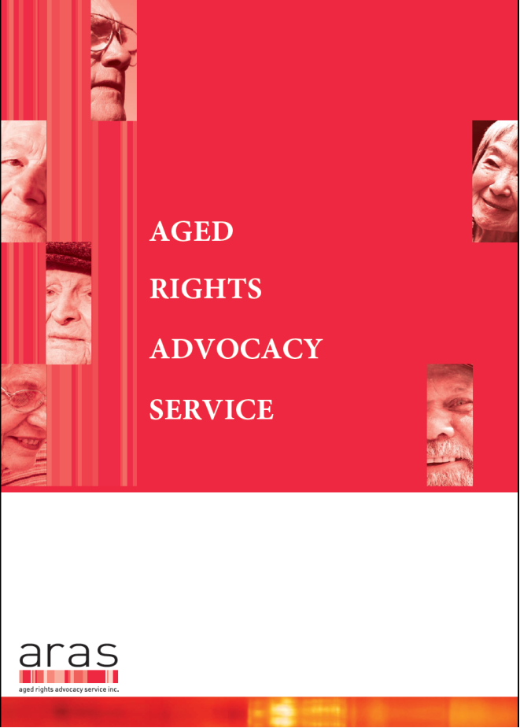



Elder Rights Advocacy



