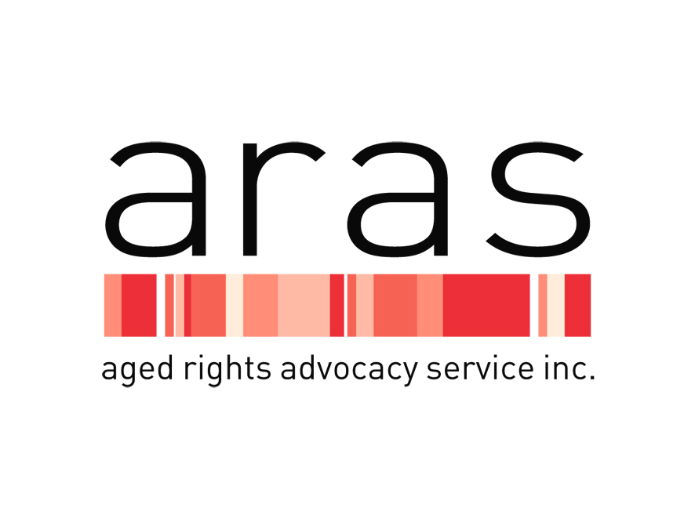

**POSITION DESCRIPTION**

|  |  |  |  |
| --- | --- | --- | --- |
| **Position:** | Legal Practitioner | **Reports to:** | Supervising Legal Practitioner |
| **Award:** | SCHADS Award | **Classification:** | SCHADS Award 6 |
| **Status:** | Full-time | **Location:** | 175 Fullarton Road, Dulwich, 5065 |

**ARAS clients**

ARAS and its Advocates work with vulnerable older people, or their representatives, who are:

• seeking or receiving Commonwealth subsidised community based aged care services or residential aged care,

• living in a Retirement Village in South Australia, or

• at risk of or experiencing abuse by carers, family, or friends.

**Purpose of Role**

Working under the direction of a Supervising Legal Practitioner (senior lawyer) the main purpose of the role is to provide legal information, education, advice and support for Advocates in their work of empowering clients to make their own choices and have their legal rights and interests respected.

All legal services must be provided in a manner which is consistent with the purpose, vision, and values of ARAS, and must comply with relevant legislation, quality standards, contemporary research and practice.

The role includes the provision of high-quality legal advice and occasional representation for clients in complex and sensitive aged care related matters.

**Key Challenges**

Contribute to the legal work of ARAS through:

• the provision of high quality written and oral advice and representation to clients on complex and sensitive matters,

• drafting high quality documentation,

* assisting the senior lawyer with training and education for Advocates and staff on the scope of the legal assistance available for ARAS clients

• assisting Advocates to resolve complex legal problems on behalf of clients

• contributing to Advocates’ understanding of legislation and legislative policies affecting clients’ interests

• remaining resilient in responding to high demand and competing priorities.

**General requirements**

|  |  |
| --- | --- |
| **Key Responsibilities** | **Key Performance Indicators** |
| 1. Advice & Support | 1. Deliver high-quality legal information and advice to Advocates and clients through consultation, education, support and representation, including at SACAT as required, and visiting clients in Residential Aged Care Facilities (RACF) or other facilities to deliver legal services when appropriate and necessary. 2. Foster partnerships with other organizations and Government departments to promote ARAS services. 3. Attend and participate in staff meetings. 4. Provide advocacy support at an individual level to achieve satisfactory resolution of legal issues for clients or their representatives.   Support the work of the senior lawyer to help clients understand their rights, responsibilities and entitlements.   1. Maintain high standard client case notes in accord with the ARAS procedures. 2. Represent and promote ARAS at workshops, forums, public engagements and networking meetings. 3. Maintain up to date knowledge and understanding of the relevant legislation, guidelines, policies and procedures. |
| 1. Teamwork & Communication | 1. Demonstrate an ability to work positively and communicate effectively in a team environment to achieve service delivery excellence. 2. Maintain reliable professional communication with colleagues and management. |
| 1. Continuous Quality Improvement | * 1. Participate in and contribute to Workplace, Health and Safety activities to ensure a safe work environment for clients, staff and visitors.   2. Participate in Continuous Quality Improvement systems and any relevant quality reviews or accreditation. |
| 1. Administration & Documentation | * 1. Maintain high-level knowledge of Microsoft Office and database programs.   2. Manage time effectively to complete tasks and meet deadlines, including written communications with clients and external services.   3. Collect and record data for systemic issues and project work. |
| 1. Personal & Professional Development | * 1. Continue professional and personal development to meet changing needs of the position and the organization.   2. Participate in performance management process.   3. Attend training as identified through the performance management process, or as identified by management.   4. Maintain knowledge of Workplace, Health and Safety, anti-discrimination and equal employment opportunity and other relevant legislation.   5. Demonstrate knowledge of the organization’s policies and procedures and a commitment to keep updated on emerging changes. |
| 1. Know and apply ARAS policies and procedures | 1. Demonstrate alignment to the ARAS mission, values, and strategic plan. 2. Model and foster behaviors aligned with the ARAS Code of Conduct. 3. Manage risk and ensure compliance with WHS to the highest standards. |

**Legal practitioner - Person Specification**

A. **Essential**

The legal practitioner must:

(i) possess appropriate tertiary qualifications in law

(ii) be admitted as a practitioner of the Supreme Court of South Australia with a current unrestricted practising certificate

(iii) hold or be eligible to hold a Category A or B practising certificate, or be willing to qualify for one by undertaking a Legal Practice Management Course

(iv) have a minimum of three years’ post admission experience in legal practice or the equivalent gained within a legal department of a private sector business or government office,

(v) have excellent written, verbal communication and presentation skills.

B. **Desirable**

The legal practitioner should be able to demonstrate:

(i) professional credibility and legal ability

(ii) a capacity to work collaboratively with the senior lawyer and staff at ARAS

(iii) a capacity to deliver high level advice on complex matters of law

(iv) an ability to identify problems and formulate and implement practical courses of action

(v) an ability to achieve effective results within relatively tight time frames

(vi) an ability to make presentations to staff on legal issues and deliver internal training programs

(vii) a working knowledge of the Guardianship and Administration Act 1993, South Australian Civil and Administrative Tribunal Act 2013, Mental Health Act 2009, Advance Care Directives Act 2013 and the Consent to Medical Treatment and Palliative Care Act 1995

(viii) knowledge of file management principles within a digital practice environment

(ix) experience working with and advocating for older people, or those with a disability, and

(x) an ability to understand and apply legislation particularly the Aged Care Act 1997 and the Retirement Villages Act 1987 and related regulations, policies and procedures.

**Specific employment requirements**

* Satisfactory National Police Clearance required
* Working with Vulnerable Persons Check
* Vaccinations as required from time to time to allow entry to RACFs, at present this includes annual influenza vaccination, and COVID-19 vaccination.
* Current driving licence and willingness to drive for work purposes.
* Travel may be required within South Australia.

**MONITORING, EVALUATION AND REVIEW**

|  |  |  |  |
| --- | --- | --- | --- |
| **Status:** | APPROVED | **Control:** | Human Resources |
| **Approved by:** | CHIEF EXECUTIVE | **Version:** | 1.0 |
| **Effective Date:** | July 2024 | **Review Date:** | July 2025 |

***Acknowledgement***

*I, ………………………………………………………………………….. acknowledge that I have read and understood the key position duties described in this Position Description and agree to carry out my duties to meet these outcomes to the best of my ability. I also understand that at times I may be required to undertake additional duties relevant to the position, not listed in this statement, that fall within my competency and skill set. I have received a copy of this Position Description.*

***Employee***

Name: ____________________________________

Signed: ____________________________________ Date _______/_______/_______

***Human Resources Manager***

Name: ____________________________________

Signed: ____________________________________ Date _______/_______/_______